Assignment 2 – Project Management Plan

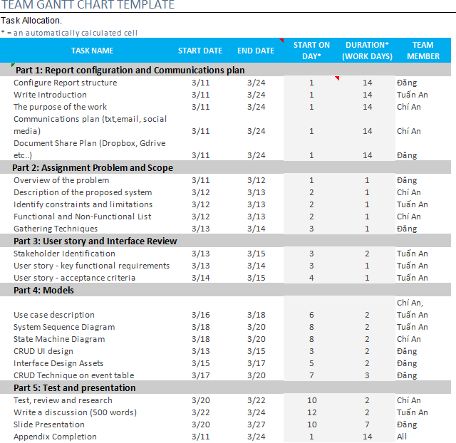

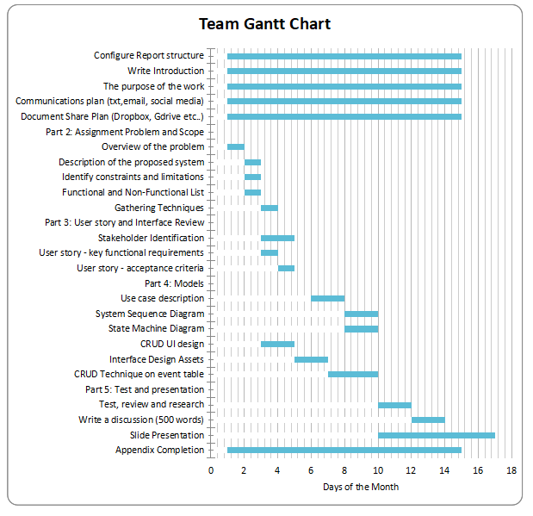
Notes:
- It is not necessary that a member contributes in every area in this statement.
- It is recognised that different members may have different levels of contribution at different stages of the project. It is a member’s total contribution to the project for the entire semester that is important.
- Measure contributions to tasks in terms of hours spent (round off to nearest hour).
- All members must agree to and sign this document.
- Tables 1 and 2 will be completed and included only in the final project management plan and submitted together with the Assignment 2 group report.

Member’s Name | Student ID | Contribution % | Signature
A: Duong Nguyen Dang | SWS01389 / 105508444 | 33.3 % | 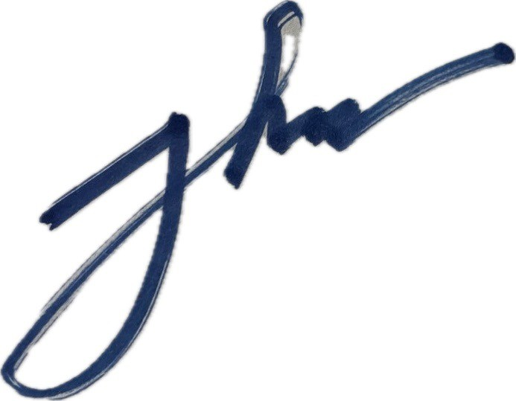
B: Huynh Tuan An | SWS02173 / 106396970 | 33.3 % | 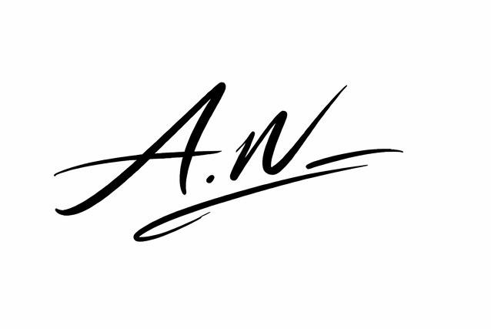
C: Lai Vu Chi An | SWS01291/  105507739 | 33.4 % | 
SUM: |  | 100%
Table 1

Table 2

 | A | B | C
Team meetings  (must meet at least 3 times) | Yes | Yes | Yes
Team management and administration | Yes | Yes | Yes
Reviewing Checking and correcting other’s work | Yes | Yes | Yes

